CURRICULUM VITAE

Amr Ibrahem M. Ahmed,  Department of Statistics, Mathematics and Insurance,  Faculty of Commerce,  Assiut University,  71515 Assiut,  Arab Republic of Egypt | 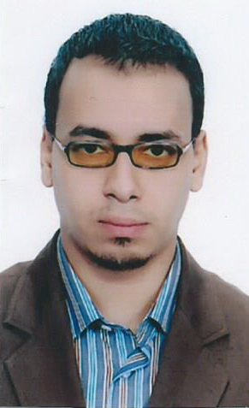  Fax: +20-88-337122  e-mail: amr.barakat1@hotmail.com

Date of birth: July 25th 1985.
Nationality: Egyptian.
Languages: Arabic, English.

Research Interests: insurance markets, insurance economics, actuarial mathematics, and enterprise risk management.

Education:
Sept. 2002-Jun. 2006: B.Sc. in Insurance from Faculty of Commerce, Assiut University, Egypt
Sept. 2008-Jun. 2012: M.Sc. in Insurance from Assiut University, Egypt. (Adviser: Prof. Safia Ahmed Abu-Bakr.)

Employment:
Jan. 2009-Jul. 2012: Demonstrator, Department of Statistics, Mathematics and Insurance, Faculty of Commerce, Kafr El-shiekh University.
Jul. 2012-Dec.2013: Assistant Lecturer, Department of Statistics, Mathematics and Insurance, Faculty of Commerce, Kafr El-shiekh University.
Dec.2013- present: Assistant Lecturer, Department of Statistics, Mathematics and Insurance, Faculty of Commerce Assiut University.

Teaching Experience: I teach the application hours of the following courses in Arabic and English:
- Insurance and risk management
- Financial Mathematics
- Commercial applications using the computer
- Principals of statistics
- Applied statistics
- Operation research

